**Implementing a Dynamic Memory Allocation Simulation**

**Introduction:**

This project aims to demonstrate how operating systems manage memory dynamically using different memory allocation strategies. We implemented a simulator in Python using **CustomTkinter**, with a focus on the **First Fit** algorithm. The application supports memory allocation, deallocation (based on process burst time), and fragmentation reporting.

**Overview of Memory Allocation Algorithms:**

| **Algorithm** | **Description** | **Pros** | **Cons** |
| --- | --- | --- | --- |
| **First Fit** | Allocates the first memory block that is large enough | Fast, simple implementation | Can lead to fragmentation over time |
| **Best Fit** | Allocates the smallest block that fits the process | Reduces memory waste initially | Slower, increases external fragmentation |
| **Worst Fit** | Allocates the largest available block | May leave large free blocks later | High fragmentation risk, inefficient |
| **Next Fit** | Like First Fit, but continues search from last allocated block | Slightly better performance than First Fit in some cases | Still prone to fragmentation |

**Justification for Choosing First Fit**:

* Offers **efficient performance** with minimal search time.
* Suitable for a basic simulation and easy to debug.
* Helps visualize fragmentation handling effectively with merging.

**Initial Stage Memory Blocks:**

| **Block Size** | **Status:** |
| --- | --- |
| 2KB | Free |
| 120KB | Occupied (P1) |
| 20KB | Free |
| 150KB | Occupied (P2) |
| 160KB | Free |
| 1KB | Occupied (P3) |
| 4KB | Free |
| 554KB | Occupied (P4) |
| 124KB | Free |

**Design And Implementation:**

The memory allocation simulator is designed using an object-oriented approach with two core classes: MemoryBlock and Process. It implements the **First Fit allocation algorithm**, which allocates the first suitable free block for each process. If the block is larger than needed, it is split; if exact, it is directly assigned.

Memory is automatically deallocated after the process’s burst time using **Python threading**, simulating real-time execution. Adjacent free blocks are **merged** post-deallocation to minimize fragmentation.

A modern **GUI built with CustomTkinter** visualizes memory blocks and allocation status in real-time. The simulator also includes a **fragmentation report generator**, giving insights into memory usage and external fragmentation. The overall design emphasizes modularity, interactivity, and educational clarity.

# **Source Code:**

|  |
| --- |
| import customtkinter as ctk  import threading  import time  from tkinter import messagebox  # Define memory block structure  class MemoryBlock:  def __init__(self, size, is_free=True, process_id=None):  self.size = size  self.is_free = is_free  self.process_id = process_id  # Define process structure  class Process:  def __init__(self, id, memory_required, burst_time):  self.id = id  self.memory_required = memory_required  self.burst_time = burst_time  # Simulator class  class MemorySimulatorApp:  def __init__(self, root):  self.root = root  self.root.title("First Fit Memory Allocation Simulator")  self.root.geometry("1100x700")  self.root.resizable(True, True)  ctk.set_appearance_mode("System")  ctk.set_default_color_theme("blue")  self.memory_blocks = [  MemoryBlock(2),  MemoryBlock(120, is_free=False, process_id="P1"),  MemoryBlock(20),  MemoryBlock(150, is_free=False, process_id="P2"),  MemoryBlock(160),  MemoryBlock(1, is_free=False, process_id="P3"),  MemoryBlock(4),  MemoryBlock(554, is_free=False, process_id="P4"),  MemoryBlock(124),  ]  self.main_frame = ctk.CTkFrame(self.root)  self.main_frame.pack(expand=True, fill="both", padx=20, pady=20)  self.memory_frame_container = ctk.CTkFrame(self.main_frame)  self.memory_frame_container.pack(side="top", fill="x", padx=10, pady=(10, 0))  self.scrollable_frame = ctk.CTkScrollableFrame(  self.memory_frame_container,  orientation="horizontal",  height=150  )  self.scrollable_frame.pack(fill="x", expand=True)  self.legend_frame = ctk.CTkFrame(self.main_frame)  self.legend_frame.pack(fill="x", pady=(10, 5))  ctk.CTkLabel(self.legend_frame, text="🟩 Free", text_color="#4CAF50").pack(side="left", padx=10)  ctk.CTkLabel(self.legend_frame, text="🔴 Allocated", text_color="#F44336").pack(side="left", padx=10)  input_frame = ctk.CTkFrame(self.main_frame, width=300)  input_frame.pack(side="top", fill="x", pady=10)  ctk.CTkLabel(input_frame, text="Add New Process", font=ctk.CTkFont(size=18, weight="bold")).pack(pady=(10, 10))  self.id_entry = ctk.CTkEntry(input_frame, placeholder_text="Process ID")  self.id_entry.pack(pady=5, padx=20)  self.size_entry = ctk.CTkEntry(input_frame, placeholder_text="Memory Required (KB)")  self.size_entry.pack(pady=5, padx=20)  self.burst_entry = ctk.CTkEntry(input_frame, placeholder_text="Burst Time (s)")  self.burst_entry.pack(pady=5, padx=20)  ctk.CTkButton(input_frame, text="Allocate Process", command=self.handle_submit).pack(pady=20)  ctk.CTkButton(self.main_frame, text="Generate Fragmentation Report", command=self.generate_fragmentation_report).pack(pady=10)  self.status_label = ctk.CTkLabel(self.main_frame, text="Status: Ready", text_color="white", anchor="w")  self.status_label.pack(fill="x", pady=(10, 5), padx=10)  self.render_memory()  def render_memory(self):  for widget in self.scrollable_frame.winfo_children():  widget.destroy()  for block in self.memory_blocks:  color = "#4CAF50" if block.is_free else "#F44336"  label_text = f"{block.size} KB\n{'Free' if block.is_free else block.process_id}"  lbl = ctk.CTkLabel(  self.scrollable_frame,  text=label_text,  fg_color=color,  text_color="white",  corner_radius=8,  height=100,  width=max(60, block.size),  anchor="center"  )  lbl.pack(side="left", padx=4, pady=10)  def handle_submit(self):  try:  pid = self.id_entry.get().strip()  memory_required = int(self.size_entry.get().strip())  burst_time = int(self.burst_entry.get().strip())  if pid and memory_required > 0 and burst_time > 0:  process = Process(pid, memory_required, burst_time)  self.allocate_memory(process)  self.id_entry.delete(0, 'end')  self.size_entry.delete(0, 'end')  self.burst_entry.delete(0, 'end')  except ValueError:  messagebox.showerror("Error", "Invalid input. Enter valid numbers.")  def allocate_memory(self, process):  for i, block in enumerate(self.memory_blocks):  if block.is_free and block.size >= process.memory_required:  if block.size > process.memory_required:  remaining = block.size - process.memory_required  self.memory_blocks[i] = MemoryBlock(process.memory_required, is_free=False, process_id=process.id)  self.memory_blocks.insert(i + 1, MemoryBlock(remaining))  else:  block.is_free = False  block.process_id = process.id  self.render_memory()  self.update_status(f"✅ Allocated Process {process.id} ({process.memory_required}KB)")  threading.Thread(target=self._deallocate_after_burst, args=(process,), daemon=True).start()  return  self.update_status(f"❌ Allocation failed for Process {process.id}")  messagebox.showwarning("Allocation Failed", f"⚠ Process {process.id} could not be allocated.")  def _deallocate_after_burst(self, process):  time.sleep(process.burst_time)  self.root.after(0, lambda: self._free_and_render(process))  def _free_and_render(self, process):  for block in self.memory_blocks:  if block.process_id == process.id:  block.is_free = True  block.process_id = None  break  self.merge_free_blocks()  self.render_memory()  self.update_status(f"ℹ Process {process.id} completed and memory deallocated.")  def merge_free_blocks(self):  i = 0  while i < len(self.memory_blocks) - 1:  if self.memory_blocks[i].is_free and self.memory_blocks[i+1].is_free:  self.memory_blocks[i].size += self.memory_blocks[i+1].size  del self.memory_blocks[i+1]  else:  i += 1  def update_status(self, message):  self.status_label.configure(text=f"Status: {message}")  def generate_fragmentation_report(self):  free_blocks = [block for block in self.memory_blocks if block.is_free]  total_free = sum(block.size for block in free_blocks)  total_used = sum(block.size for block in self.memory_blocks if not block.is_free)  total_size = sum(block.size for block in self.memory_blocks)  largest_free_block = max((block.size for block in free_blocks), default=0)  external_fragmentation = total_free - largest_free_block if len(free_blocks) > 1 else 0  external_fragmentation_percent = (external_fragmentation / total_size) * 100 if total_size > 0 else 0  internal_fragmentation = 0  internal_fragmentation_percent = 0  report_window = ctk.CTkToplevel(self.root)  report_window.title("Fragmentation Report")  report_window.geometry("400x300")  report_window.resizable(False, False)  report_window.grab_set()  report_window.focus()  report_window.configure(fg_color="white")  report_frame = ctk.CTkFrame(report_window, fg_color="white")  report_frame.pack(fill="both", expand=True, padx=20, pady=20)  ctk.CTkLabel(  report_frame,  text="FRAGMENTATION REPORT",  font=ctk.CTkFont(size=14, weight="bold"),  text_color="black",  anchor="w",  justify="left"  ).pack(fill="x", pady=(0, 10))  ctk.CTkLabel(report_frame, text=f"Total memory: {total_size} KB", font=ctk.CTkFont(size=12), text_color="black").pack(fill="x", pady=2)  ctk.CTkLabel(report_frame, text=f"Memory used: {total_used} KB", font=ctk.CTkFont(size=12), text_color="black").pack(fill="x", pady=2)  ctk.CTkLabel(report_frame, text=f"Memory free: {total_free} KB", font=ctk.CTkFont(size=12), text_color="black").pack(fill="x", pady=2)  ctk.CTkLabel(report_frame, text=f"Number of free blocks: {len(free_blocks)}", font=ctk.CTkFont(size=12), text_color="black").pack(fill="x", pady=2)  ctk.CTkLabel(report_frame, text=f"Largest free block: {largest_free_block} KB", font=ctk.CTkFont(size=12), text_color="black").pack(fill="x", pady=2)  ctk.CTkLabel(report_frame, text=f"External fragmentation: {external_fragmentation} KB ({external_fragmentation_percent:.2f}%)", font=ctk.CTkFont(size=12), text_color="black").pack(fill="x", pady=2)  ctk.CTkLabel(report_frame, text=f"Internal fragmentation: {internal_fragmentation} KB ({internal_fragmentation_percent:.2f}%)", font=ctk.CTkFont(size=12), text_color="black").pack(fill="x", pady=2)  ctk.CTkLabel(report_frame, text="Note: Internal fragmentation is 0 because blocks are split to fit processes exactly.", font=ctk.CTkFont(size=10), text_color="black", wraplength=350).pack(fill="x", pady=2)  ctk.CTkButton(report_frame, text="Close", command=report_window.destroy).pack(pady=10)  if __name__ == "__main__":  root = ctk.CTk()  app = MemorySimulatorApp(root)  root.mainloop() |

**Graphical User Interface:**

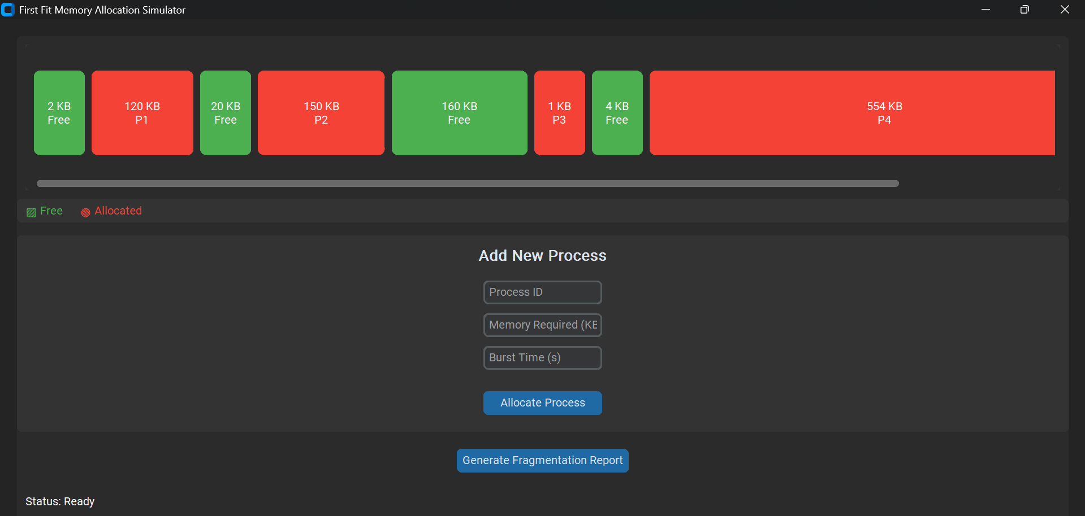

**P5 Allocation Request of 15KB:**

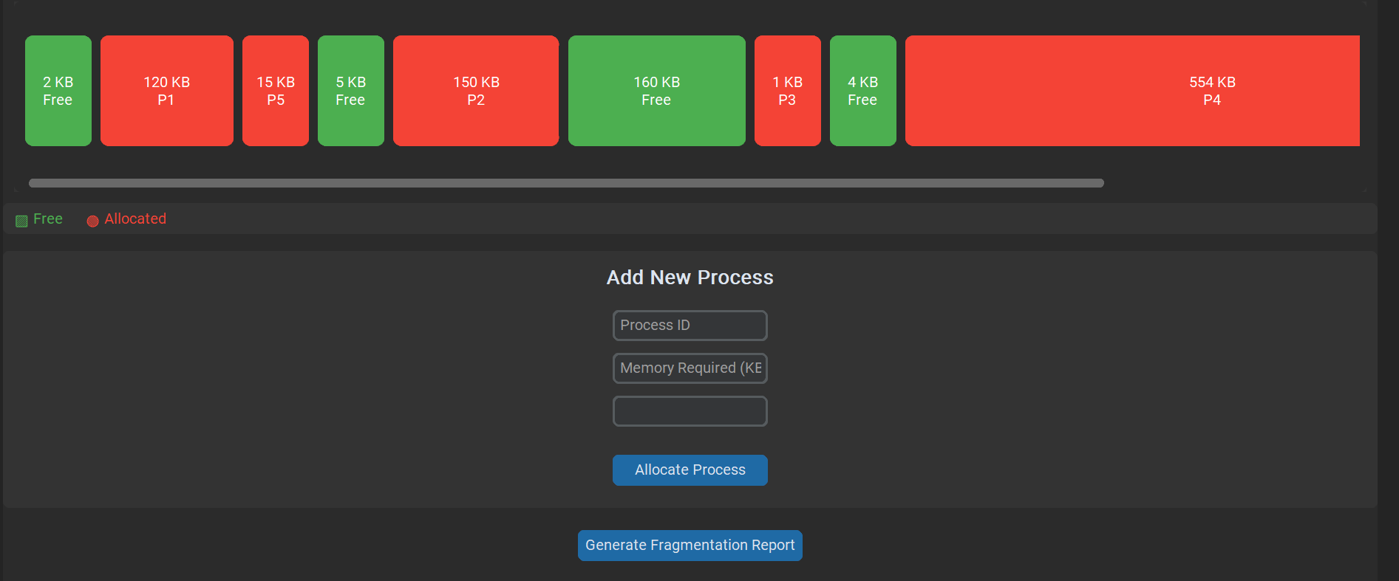

**P6 Allocation Request of 100KB:**

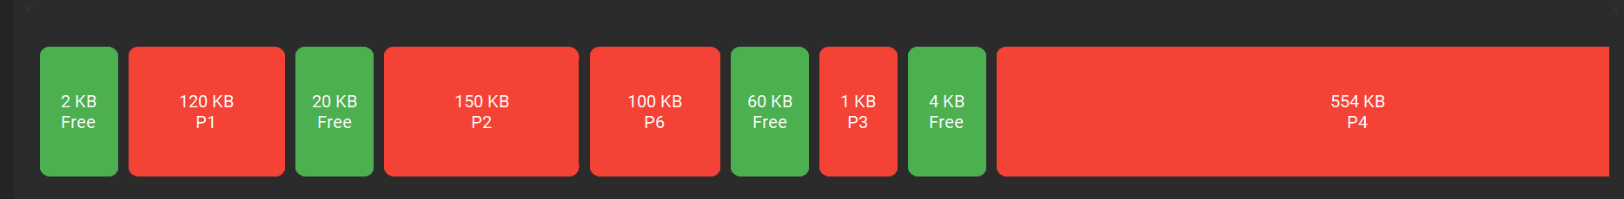

**P7 Allocation Request of 5KB:**

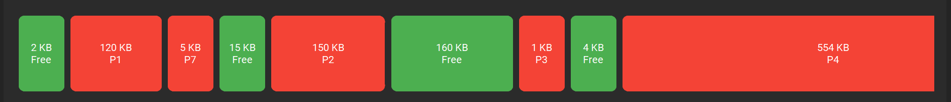

**P8 Allocation Request of 200KB:**

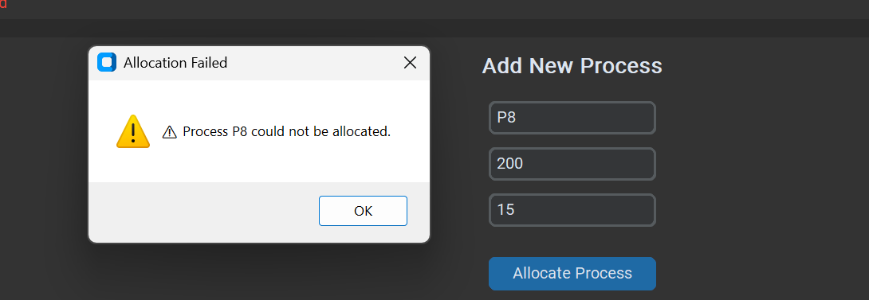

**P9 Allocation Request of 3KB:** 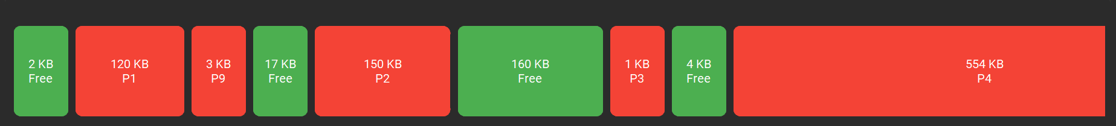

**Fragmentation Report:**

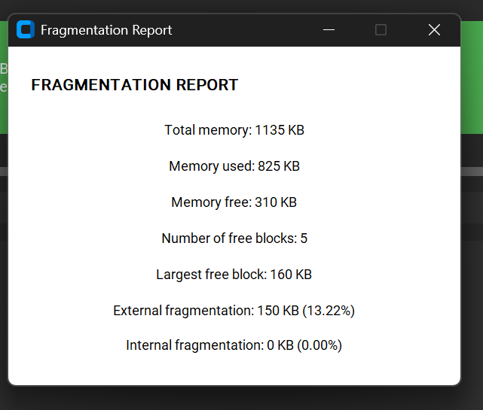

**Analysis And Discussion:**

**1. Internal Fragmentation**

No internal fragmentation occurs. This is because the simulator splits free blocks exactly to the size required by the process. Any remaining space after allocation becomes a new free block.

**Result:**

* internal_fragmentation = 0 KB
* internal_fragmentation_percent = 0%

**2. External Fragmentation**

Free blocks are scattered throughout the memory. Even if total free memory is large, a process may fail to allocate if no **single block** is large enough.

Total free memory = 310 KB and largest free block = 160 KB, then:

external_fragmentation = 150 KB

**3. Memory Utilization**

**In the simulator:**

* Memory used = sum of all allocated blocks
* Memory utilization % = (total_used / total_size) * 100

**Good utilization occurs when:**

* Large free blocks are merged.
* Few small unusable holes exist.

**Conclusion**

The implemented **First Fit memory allocator** effectively demonstrates dynamic memory management within an operating system environment. While simple, it reflects real-world trade-offs between allocation speed and memory fragmentation. Visual and functional design helps users grasp core OS concepts intuitively.